1.

2.

import java.util.Scanner;

class Inttodec

{

public static void main(String args[])

{

Scanner a=new Scanner(System.in);

int c=a.nextInt();

double b=(double)c;

System.out.printf("The double value is %.2f",b/100);

}

}



3. import java.util.Scanner;

class Round{

public static void main(String[] args)

{ Scanner scanner = new Scanner(System.in);

double myDouble = scanner.nextDouble();

int myInt = (int) myDouble;

System.out.println(myInt);

}

}



4. import java.util.Scanner;

public class Salary {

public static void main(String[] args) {

Scanner sc = new Scanner(System.in);

int m = sc.nextInt();

double n= sc.nextDouble();

double k= m\*(n/100);

double a= m+k;

System.out.println(a);

}

}

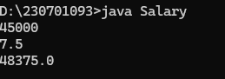

5.